**https://drive.google.com/file/d/1o6WXJHqkC1uAbA2eXzN5UkwiLOQ1Kl4f/view?usp=sharing**

# AeroFit Business Case Study

##### *Business Problem*

The market research team at AeroFit wants to identify the characteristics of the target audience for each type of treadmill offered by the company, to provide a better recommendation of the treadmills to the new customers. The team decides to investigate whether there are differences across the product concerning customer characteristics.

Perform descriptive analytics to create a customer profile for each AeroFit treadmill product by developing appropriate tables and charts. For each AeroFit treadmill product, construct two-way contingency tables and compute all conditional and marginal probabilities along with their insights/impact on the business.

**Tasks to do:**

we have to Identify the target audience for each product from the data. and give recommendations according to the characterization of those customers.

Investigate whether there are differences across the product concerning customer characteristics

**Data Exploration and Insight:**

### Data parameters

* Product Purchased: KP281, KP481, or KP781
* Age: In years
* Gender: Male/Female
* Education: In years
* marital status: Single or partnered
* Usage: The average number of times the customer plans to use the treadmill each week.
* Income: Annual income (in USD)
* Fitness: Self-rated fitness on a 1-to-5 scale where 1 is the poor shape and 5 is the excellent shape.
* Miles: The average number of miles the customer expects to walk/run each week

AeroFit case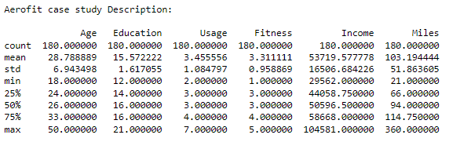 study, the shape is (180, 9)

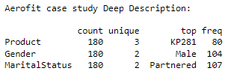

##### *Observation 01:*

* Median Age of Customer is 26 years
* Top selling product is KP281 with the highest number of units sold (80)
* Maximum users are Married Men.
* Average fitness level of the customers is 3
* Average miles for giving customers are 94 Miles
* Average income of the customers is $ 50596.5.
* On average, customers use the treadmill 3 days per week.
* Highest mile covered in a single-use by a customer is 90. (And after a deep analysis we found out, that it's a male customer)

## Customer Analysis

## Gender distribution of customers

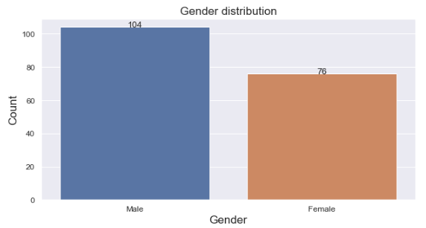

### Marital Status based Customer distribution

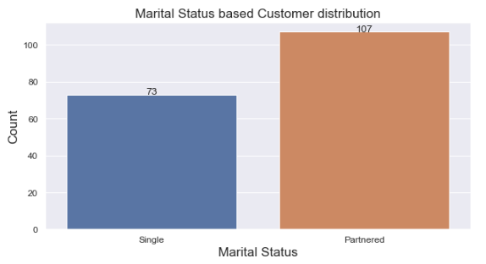

Age distribution

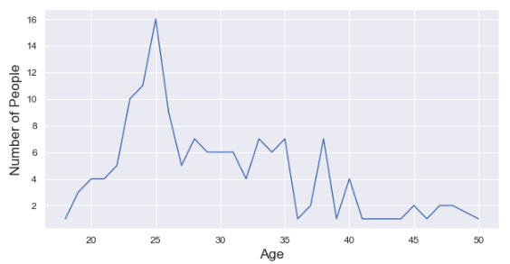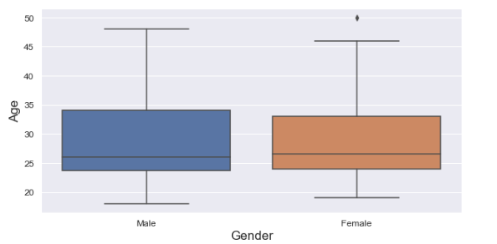

### Miles-based customers distribution

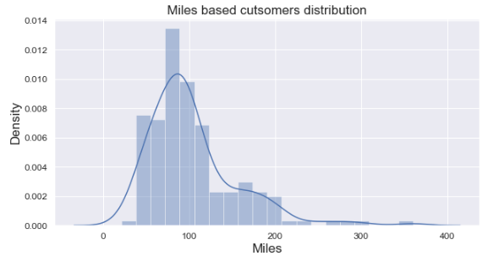

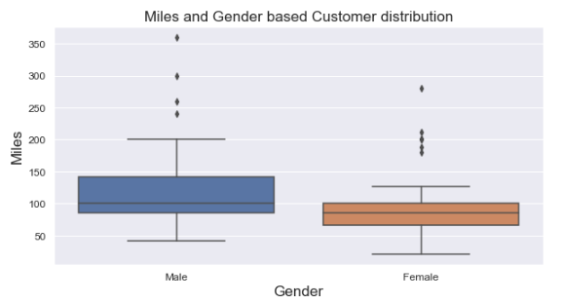

### Checking for Outliers in Miles

Q1 = 66.0, Q3 = 114.75, IQR = 48.75

Outliers: 13

Customers who run more than 187.875 (outliers).

KP781 11

KP281 1

KP481 1

### Income-based Gender distribution

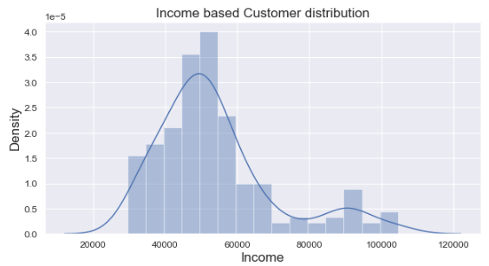

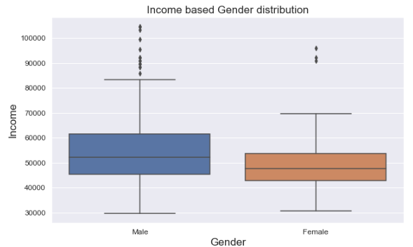

##### *Observation 02:*

* there are 19 customers, who have Income way above the other customers in the data

### Checking for Outliers in customer

### Income

Q1 = 44058.75, Q3 = 58668.0,

IQR = 14609.25

False 161

True 19

## Product Analysis

### Product distribution

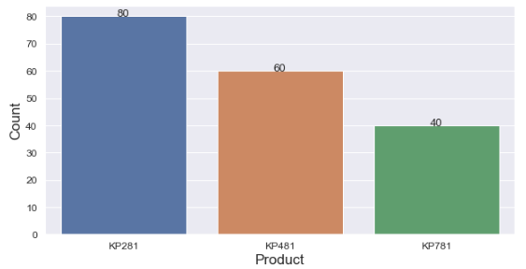

### Revenue base product distribution

|  | **Product** | **Product revenue** |
| --- | --- | --- |
| **0** | KP281 | 120000 |
| **1** | KP481 | 105000 |
| **2** | KP781 | 100000 |

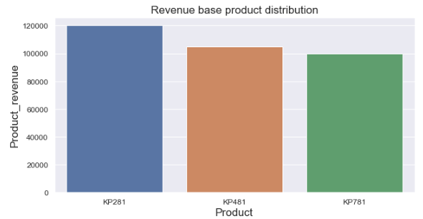

##### *Observation 03:*

* KP281 is the top-selling product and KP781 is the lowest-selling product
* KP281 is the highest revenue-generating product
* unlike the huge difference in the number of products sold between KP481 and KP781 which was 20 (33%), the difference between their revenue is only 5000 USD (4%)

### Age base product distribution

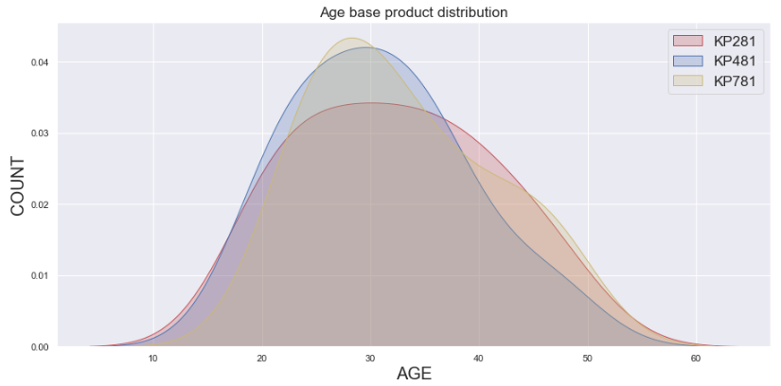

## Analysis using Multiple factors

### Gender-based on product distribution

| **Gender** | **Female** | **Male** | **All** |
| --- | --- | --- | --- |
| **Product** |  |  |  |
| **KP281** | 40 | 40 | 80 |
| **KP481** | 29 | 31 | 60 |
| **KP781** | 7 | 33 | 40 |
| **All** | 76 | 104 | 180 |

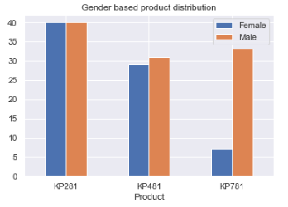

| **Gender** | **Female** | **Male** | **All** |
| --- | --- | --- | --- |
| **Product** |  |  |  |
| **KP281** | 22.222222 | 22.222222 | 44.444444 |
| **KP481** | 16.111111 | 17.222222 | 33.333333 |
| **KP781** | 3.888889 | 18.333333 | 22.222222 |
| **All** | 42.222222 | 57.777778 | 100.000000 |

#### Observation 04:

* Gender distribution in KP281 is equal to 22.22%
* In KP481, the percentage of Male customers by 1.1%.
* in PK781, the percentage of Male customers by 14.5%. And from this, we can say that when it comes to KP781 is the least favorite product of Female customers and on the other hand 2nd most sold product for Male customers.
* Marginal Probability for each product is:

KP281 = 44.4 %

KP481 = 33.3 %

KP781 = 22.2 %

* Marginal Probability for each Gender is:

Male = 57.7 %

Female = 42.2 %

The probability that particular gender will buy a particular product is shown below:

| **Gender** | **Female** | **Male** | **All** |
| --- | --- | --- | --- |
| **Product** |  |  |  |
| **KP281** | 52.631579 | 38.461538 | 44.444444 |
| **KP481** | 38.157895 | 29.807692 | 33.333333 |
| **KP781** | 9.210526 | 31.730769 | 22.222222 |

##### *Observation 05:*

* When it comes to KP281 and KP481, it is more likely that a Female customer will buy them. And KP781 on the other hand is more in demand with Male customers as compared to Female customers for that same product.

### Marital status-based product distribution

| **Marital status** | **Partnered** | **Single** | **All** |
| --- | --- | --- | --- |
| **Product** |  |  |  |
| **KP281** | 48 | 32 | 80 |
| **KP481** | 36 | 24 | 60 |
| **KP781** | 23 | 17 | 40 |
| **All** | 107 | 73 | 180 |

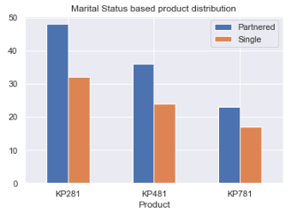

| **Marital status** | **Partnered** | **Single** | **All** |
| --- | --- | --- | --- |
| **Product** |  |  |  |
| **KP281** | 26.666667 | 17.777778 | 44.444444 |
| **KP481** | 20.000000 | 13.333333 | 33.333333 |
| **KP781** | 12.777778 | 9.444444 | 22.222222 |
| **All** | 59.444444 | 40.555556 | 100.000000 |

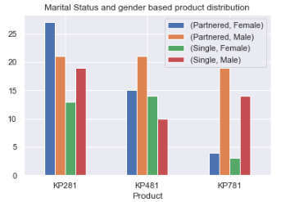

##### *Observation 06:*

* Marginal Probability for
* Married Customer: 59.44 %

Single Customer: 40.555 %

* + there is an 18.9% higher chance of a customer being partnered as compared to being single.
  + KP281 is most popular among Partnered Females
  + KP481 is most popular among Partnered Males
  + KP781 is most popular among Partnered Males

The Probability of a customer being single or partnered according to the particular product they purchase is given below

| **Marital status** | **Partnered** | **Single** | **All** |
| --- | --- | --- | --- |
| **Product** |  |  |  |
| **KP281** | 0.448598 | 0.438356 | 0.444444 |
| **KP481** | 0.336449 | 0.328767 | 0.333333 |
| **KP781** | 0.214953 | 0.232877 | 0.2222Education-based |

### Education-based Product distribution

| **Product** | **KP281** | **KP481** | **KP781** | **All** |
| --- | --- | --- | --- | --- |
| **Education** |  |  |  |  |
| **12** | 2 | 1 | 0 | 3 |
| **13** | 3 | 2 | 0 | 5 |
| **14** | 30 | 23 | 2 | 55 |
| **15** | 4 | 1 | 0 | 5 |
| **16** | 39 | 31 | 15 | 85 |
| **18** | 2 | 2 | 19 | 23 |
| **20** | 0 | 0 | 1 | 1 |
| **21** | 0 | 0 | 3 | 3 |
| **All** | 80 | 60 | 40 | 180 |

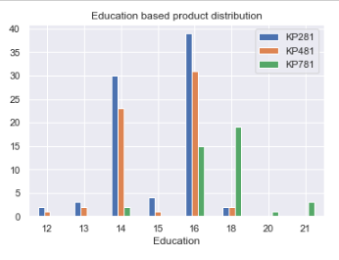

##### *Observation 07:*

* Product KP281 and KP481 are more popular among customers who have education between 14 to 16
* product KP781 is purchased by customers of education 16 and above.
* This is because Education and Income have a positive and high correlation, and Product price and Income also have a positive and high correlation. That is the main reason KP781 which is a higher variant of the treadmill with a higher price is so popular because of the high income of the customers.

### Usage-based product distribution

| **Product** | **KP281** | **KP481** | **KP781** | **All** |
| --- | --- | --- | --- | --- |
| **Usage** |  |  |  |  |
| **2** | 19 | 14 | 0 | 33 |
| **3** | 37 | 31 | 1 | 69 |
| **4** | 22 | 12 | 18 | 52 |
| **5** | 2 | 3 | 12 | 17 |
| **6** | 0 | 0 | 7 | 7 |
| **7** | 0 | 0 | 2 | 2 |
| **All** | 80 | 60 | 40 | 180 |

| **Product** | **KP281** | **KP481** | **KP781** |
| --- | --- | --- | --- |
| **Usage** |  |  |  |
| **2** | 23.75 | 23.333333 | 0.0 |
| **3** | 46.25 | 51.666667 | 2.5 |
| **4** | 27.50 | 20.000000 | 45.0 |
| **5** | 2.50 | 5.000000 | 30.0 |
| **6** | 0.00 | 0.000000 | 17.5 |
| **7** | 0.00 | 0.000000 | 5.0 |

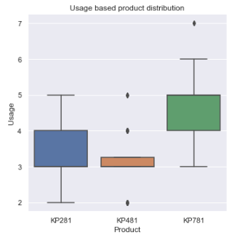

##### *Observation 08:*

* customers who treadmill 6 to 7 days per week are most likely to use KP781
* KP281 and KP481 users are the ones who use their treadmill 2 to 4 days per week.

### Fitness-based product distribution:

| **Product** | **KP281** | **KP481** | **KP781** | **All** |
| --- | --- | --- | --- | --- |
| **Fitness category** |  |  |  |  |
| **Average Shape** | 54 | 39 | 4 | 97 |
| **Bad Shape** | 14 | 12 | 0 | 26 |
| **Excellent Shape** | 2 | 0 | 29 | 31 |
| **Good Shape** | 9 | 8 | 7 | 24 |
| **Poor Shape** | 1 | 1 | 0 | 2 |
| **All** | 80 | 60 | 40 | 180 |

| **Product** | **KP281** | **KP481** | **KP781** |
| --- | --- | --- | --- |
| **Fitness category** |  |  |  |
| **Average Shape** | 67.50 | 65.000000 | 10.0 |
| **Bad Shape** | 17.50 | 20.000000 | 0.0 |
| **Excellent Shape** | 2.50 | 0.000000 | 72.5 |
| **Good Shape** | 11.25 | 13.333333 | 17.5 |
| **Poor Shape** | 1.25 | 1.666667 | 0.0 |

##### *Observation 09:*

* if the person is in excellent shape probability that he is using KP781 is more than 70%.

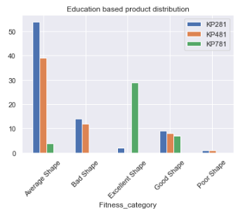

### Gender wise Miles per use

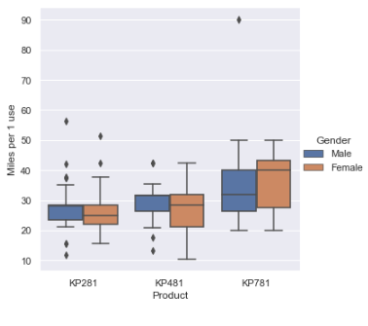

##### *Observation 10:*

##### Female Customers who are running an average of 40 miles/usage (extensive exercise), are using product KP781, which is higher than the Male average using the same product.

##### KP781 can be recommended for Female customers who exercise extensively.

##### Male customers who are running an average of 28 miles/usage (average exercise), are using product KP281.

##### Male customers who are running an average of 32 miles/usage (average exercise), are using product KP481. and for females average running for the same product is 28 miles/usage.

### Fitness category analysis

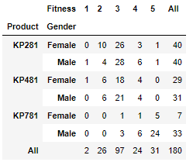

##### *Observation 11:*

* Majority of customers who are in Excellent shape, use KP781
* Majority of customers who are in Average shape, use KP281
* combined fitness level of Male and Female customers who uses KP281 is equal.
* Mile customers who use KP781 are the second-highest group of people in the fitness category.

### Miles-based Product distribution

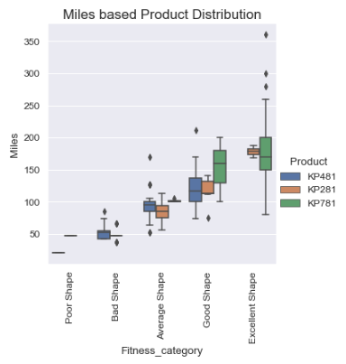

##### *Observation 12:*

##### People who run/walk more miles (>130), are more likely to use the KP781 product.

##### People who walk/run around 60 to 130 miles are more likely to use KP281 and KP481 products.

### Correlations between all features

|  | **Age** | **Education** | **Usage** | **Fitness** | **Income** | **Miles** | **Product price** | **Miles per 1 use** |
| --- | --- | --- | --- | --- | --- | --- | --- | --- |
| **Age** | 1.000000 | 0.280496 | 0.015064 | 0.061105 | 0.513414 | 0.036618 | 0.029263 | 0.012678 |
| **Education** | 0.280496 | 1.000000 | 0.395155 | 0.410581 | 0.625827 | 0.307284 | 0.563463 | 0.069552 |
| **Usage** | 0.015064 | 0.395155 | 1.000000 | 0.668606 | 0.519537 | 0.759130 | 0.623124 | 0.156523 |
| **Fitness** | 0.061105 | 0.410581 | 0.668606 | 1.000000 | 0.535005 | 0.785702 | 0.696616 | 0.557926 |
| **Income** | 0.513414 | 0.625827 | 0.519537 | 0.535005 | 1.000000 | 0.543473 | 0.695847 | 0.267164 |
| **Miles** | 0.036618 | 0.307284 | 0.759130 | 0.785702 | 0.543473 | 1.000000 | 0.643923 | 0.734778 |
| **Product price** | 0.029263 | 0.563463 | 0.623124 | 0.696616 | 0.695847 | 0.643923 | 1.000000 | 0.337825 |
| **Miles per 1 use** | 0.012678 | 0.069552 | 0.156523 | 0.557926 | 0.267164 | 0.734778 | 0.337825 | 1.000000 |

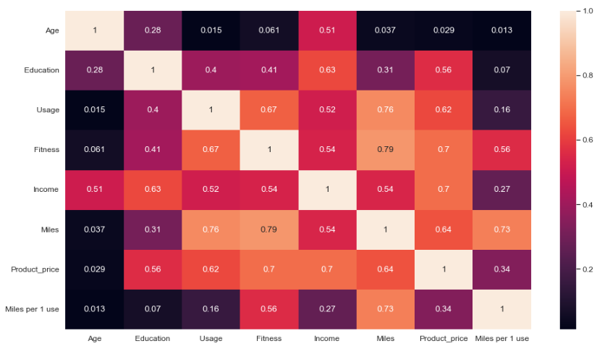

#### Correlation: >0.6

Usage Fitness 0.668606

Miles 0.759130

Fitness Usage 0.668606

Miles 0.785702

Product price 0.696616

Income Product price 0.695847

Miles Usage 0.759130

Fitness 0.785702

Miles per 1 use 0.734778

Product price Fitness 0.696616

Income 0.695847

Miles per 1 use Miles 0.734778

##### *Observation 13:*

* Fitness and Miles have a positive and a very high correlation: 0.79
* Product price and Income have a positive and a very high correlation: 0.7

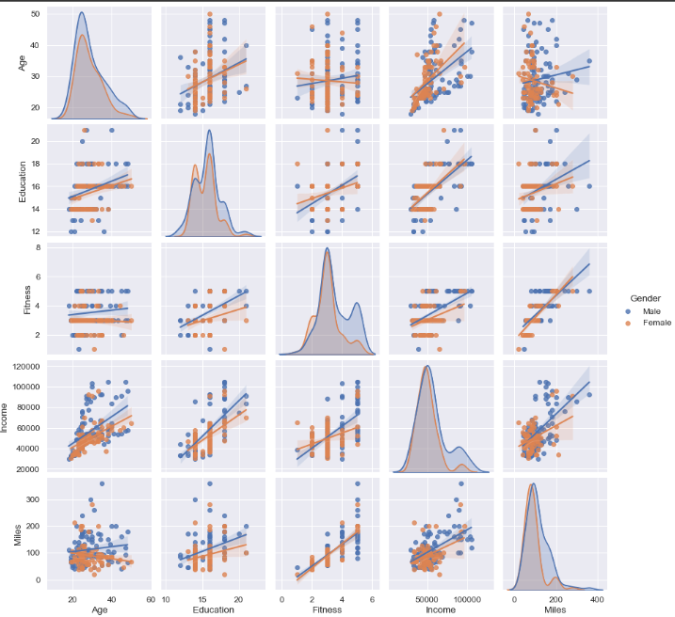

**From observations 1 to 12, we can make a customer profile for particular products:**

KP281:

* Most affordable and entry-level and Maximum Selling Product.
* This model popular amongst both Male and Female customers
* The Same number of Male and Female customers.
* Customers walk/run an average of 70 to 90 miles on this product.
* Customers use 3 to 4 times a week
* Fitness Level of this product users is Average Shape.
* More general purpose for all age groups and fitness levels.

KP481:

* Intermediate Price Range
* Fitness Level of this product users varies from Bad to Average Shape depending on their usage.
* Customers prefer the KP481 model to use less frequently but to run more miles per week on this.
* Customer walks/runs an average of 70 to 130 or more miles per week on his product.
* has a higher probability of selling to female customers.
* Probability of Female customers buying KP481 is significantly higher than male.
* KP481 product is specifically recommended for Female customers who are intermediate users.
* customers are from the adult, teen, and mid-age categories.

KP781:

* least sold product.
* high price and preferred by customers who do exercises more extensively and run more miles.
* Customer walks/runs an average of 120 to 200 or more miles per week on his product.
* Customers use 4 to 5 times a week at least.
* If a person is in Excellent Shape, the probability that he is using KP781 is more than 90%.
* Female Customers who are running an average of 180 miles (extensive exercise), are using product KP781, which is higher than the Male average using the same product.
* KP781 can be recommended for Female customers who exercise extensively.
* Probability of Male customers buying Product KP781(31.73%) is way more than female (9.21%).
* Probability of a single person buying KP781 is higher than Married customers. So, KP781 is also recommended for people who are single and exercise more.
* most old people who are above 45 age and adult-use this product.

**Recommendations:**

* Recommend KP781 product to users who exercise/run more frequently and run more and more miles, and have a high income. Since Kp781 is the least selling product (22.2% share of all the products), recommend this product to some customers who exercise at an intermediate to extensive level, if they are planning to go for KP481. Also, the targeted Age Category is adults and ages above 45.
* Recommend KP481 product specifically for female customers who run/walk more miles, as data shows their probability is higher. Statistical Summary about fitness level and miles for KP481 is not good as KP281 which is a cheaper product. Possibly because of price, customers prefer to purchase KP281. It is recommended to make some necessary changes to product K481 to increase customer experience.